MSC SUSTAINABLE FISHERIES CERTIFICATION

INCIDDENTAL REMOVAL OF ATLANTIC SEABOB BY FISHING VESSELS
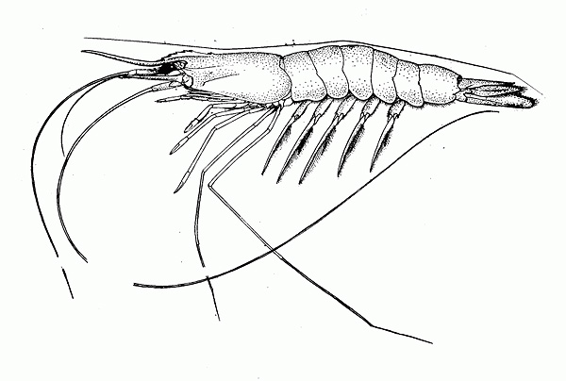

Prepared by: Yolanda Babb-Echteld ( Fisheries Department)

March 2016

Seabob removal other than Seabob trawlers

Estimation are made for the following fishery types:
- Industriele seabob catch.
The seabob obserser program is intended to be conducted at least ones a month on a vessel at Heiploeg or SAIL. In 2015, 5 trips were conducted and the information of 4 is below. The other trip was conducted on Sechong 29, Korean vessel at SAIL. This trip was special, because at the same time the 3½ inch TTED was used. Data collection was not adequate in March.

The seabob catch retained is around 79-80% of the total catch. From personal conversation with Tomas Willems this seems to be very high. Therefore, Fisheries Department need to check the method of estimation of the observers.

 | Noble Star I | Noble Star II | Rock Shrimp | Turbot II
TOTALE VANGST | 12430.50 | 5334.15 | 12970.00 | 12786.00
Catch retained (kg) | 10816.50 | 4635.15 | 10905.00 | 11769.00
Sea-bob | 10310.00 | 3728.00 | 10190.00 | 11370.00
Witi bere | 15.00 | 0.00 | 286.00 | 11.00
Brown shrimp | 0.00 | 404.00 | 2.00 | 0.00
shrimp (mix) | 74.50 | 0.00 | 41.00 | 118.00
Finfish | 417.00 | 479.00 | 383.00 | 270.00
Catch discarded(kg) | 1614.00 | 699.00 | 2065.00 | 1017.00
Sea-bob | 122.00 | 0.00 | 225.00 | 249.00
Witi bere | 62.00 | 0.00 | 5.00 | 0.00
Finfish | 1236 | 699 | 1708 | 616
Others | 111 | 0 | 0 | 87

 | Catch retained & Discarded in %
 | Noble Star I | Noble Star II | Rock Shrimp | Turbot II
TOTALE VANGST
Catch retained (kg) | 87.02 | 86.90 | 84.08 | 92.05
Sea-bob | 82.94 | 69.89 | 78.57 | 88.93
Witi bere | 0.12 | 0.00 | 2.21 | 0.09
Brown shrimp | 0.00 | 7.57 | 0.02 | 0.00
shrimp (mix) | 0.60 | 0.00 | 0.32 | 0.92
Finfish | 3.35 | 8.98 | 2.95 | 2.11
Catch discarded(kg) | 12.98 | 13.10 | 15.92 | 7.95
Sea-bob | 0.98 | 0.00 | 1.73 | 1.95
Witi bere | 0.50 | 0.00 | 0.04 | 0.00
Finfish | 9.94 | 13.10 | 13.17 | 4.82
Others | 0.89 | 0.00 | 0.00 | 0.68

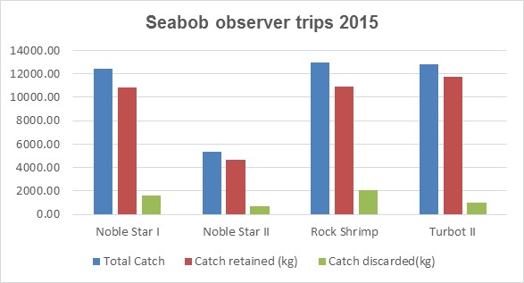

Method used to collect the data on the TTED trial 22-30 March 2015 (Mario Yspol)
- First we marked the bags of control and experimental to avoid confusion .
- Due to space concern and other practical issue we decided to process one of the bag at every haul during the day . one experimental and then at the next haul the control bag .
- Keep in mind that the seabob fisheries have in practise only two fishing grounds . We could not analyse or sample the two bags at the same time due to early mention causes .
- We use wooden board to separate the content of the bag that we would analyse from the rest of the catch.
- The following was registered of the bags that were processed (control and experimental bags) The total contents of the bags were measure using baskets and scale .
- The total bycatch of the one bag in question .
- Of the one basket chosen as sample we register: Rays ,jelly fish, trash , and all the commercial bycatch species (despite the size) taken by the crew .
- We took weight and length of all these species in the sample .
- The position of each tow and the total catch of seabob registered by the captain was also collected

Existing BRD’s (nets with square mesh panel) were sent to USA for underwater testing by NOAA by June 2014. The square mesh codend of 120 has a better performance than the other of 130, because of the water flow. The companies themselves know to whom the nets belongs.

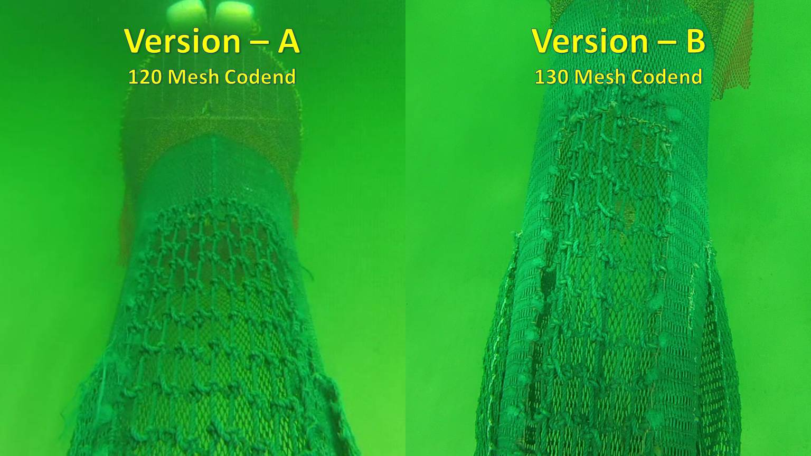
Knot Orientation
Forcing netting inwards
Knot Orientation
Forcing netting outwards

- Penaeus shrimp trawlers

With the introduction of the Vessel Monitoring System (VMS) Penaeus shrimp trawlers fishing are monitored and reports will show any vessel below the 15 fathom (± 27.5m).
There has been 2 observation on Penaeus shrimp trawlers, one in 2014, Ranmar 61 and the other one in 2015, Star Shrimper. Information of both vessels have not indicated any seabob catch. Both vessels has been fishing in depths above 70m. From literature seabob (1-70m) would not be excepted to be found in those depths. However, incidents of seabob catch may occur.

 | Ranmar 61 2014 | Star Shrimper 2015
TOTAL CATCH (kg) | 21,058.5 | 3,814.05
Catch retained | 6,185.5 | 2,584.05
Shrimp/others | 4,395 | 1,374.55
shrimp (Mix) | 4,116 | 10.5
Hopper (Pink Spotted) | 0 | 404.05
Pink | 30 | 960
Sea-bob | 0 | 0
Witi bere | 0 | 0
Crab | 90 | 0
Squid + octopus | 124 | 0
Shell fish | 35 | 0
Finfish | 1,790.5 | 1,045
Catch discarded (kg) | 14,873 | 1,230
Crab | 3,755 | 0
Squid + octopus | 150 | 0
Shell fish | 2,499 | 2
Finfish | 7,259 | 1,228

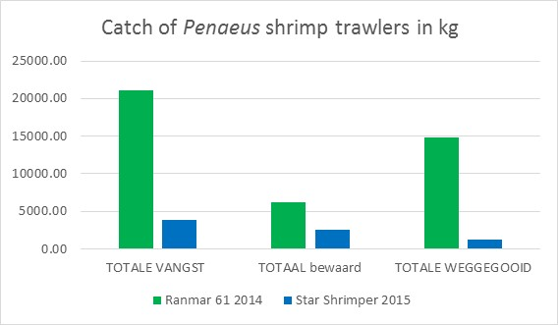

- Finfish trawl.
In 2015, the Fisheries Department was able to conduct 5 observer trips on finfish trawlers. These vessels fish in depths from 24-40m, however, they are licensed to fish from 27m and onwards. Seabob catches has been observed during 2 trips with very small amount. On Nathan, the percentage of seabob observed 0.0064% of the catch retained and on Iris this percentage of seabob was 0.033 % of the catch retained. Both catches were in different depths and in different areas and below 0.1% of the total catch.

Catches of Penaeus shrimp are common, but also in very small amounts. The percentage of discards is on average 18% of the total catch. Except for Nathan, where the discard was above 50% of the total catch. The reason was due to fishing problems, the gear did function properly. The boat had therefore, stop fishing, reporting broken trip.

 | Nathan | Minerva | Iris | Dona Isa | De 4 Gebroeders
Total Catch (KG) | KG 7,224.40 | KG 16,383.92 | KG 18,885.35 | KG 11,247.85 | KG 32,331.46
Catch retained (kg) | 3,102.4 | 13413.92 | 15,324.35 | 9,515.85 | 27,524.46
Sea-bob | 0.2 | 0 | 5 | 0 | 0
Penaeus spp | 0.2 | 4.92 | 0.15 | 0 | 4.46
Squid + octopus | 25 | 29 | 0 | 0 | 0
Finfish | 3,077 | 13,380 | 15,319 | 9,515 | 27,520
Catch discarded (kg) | 4,122 | 2,970 | 3,561 | 1,732 | 4,807
finfish | 2,622 | 2,970 | 3,561 | 1,732 | 4,807
Sea devil | 1,500 | 0 | 0 | 0 | 0

